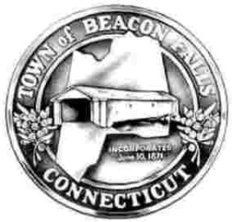

Beacon Falls Board of Selectmen

Beacon Falls Board of Finance

FY 23 Budget Workshop Agenda

May 26, 2022

Mr. Leonard Greene
Town Clerk, Town of Beacon Falls
10 Maple Avenue
Beacon Falls, CT 06403

Dear Mr. Greene:

The Beacon Falls Board of Selectmen will hold a Joint Budget Workshop with the Board of Finance on Tuesday, May 31, 2022 at 6:30 PM at the Beacon Falls Town Hall Assembly Room, 10 Maple Avenue, Beacon Falls, CT 06403.
AGENDA

- Call to Order / Pledge to the Flag

- Public Comment & Input – Webform submissions

- Open FY2023 Budget Discussion:
  - Revenue
  - Expenditures
  - Non-Recurring Capital Projects
  - Other

- Adjournment

Respectfully Submitted,

Erin Schwarz
Finance Administrative Assistant

