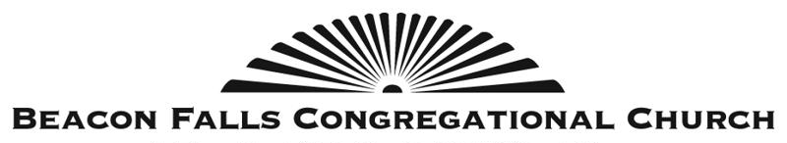
69 Wolfe Avenue
Beacon Falls, CT 06403
WWW.BEACONFALLSCONGREGATIONAL.ORG

Dear Beacon Falls Residents,

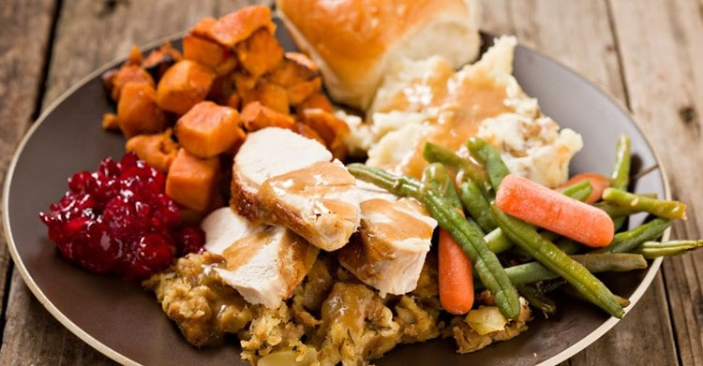
Thanksgiving is a time to thank God for all His blessings. Here at Beacon Falls Congregational Church, we are thankful for this amazing community we call home – and that includes you.
If you need a Thanksgiving meal for any reason, BFCC would be happy to prepare and provide your Turkey dinner this year!

Call or email Shannon in the BFCC church office at 203-729-8802 or secretary@beaconfallscongregational.org to order your FREE,
fully prepared (just "heat n' eat") Thanksgiving Turkey Dinner.
Kindly order on or before Wednesday November 15th.
Once ordered, we are happy to deliver to any home address in Beacon Falls on the morning of Thursday Nov. 23^{rd,} 2023 or you can pickup your meal at 10AM at Beacon Falls Congregational Church.
God bless you! We ❤ our neighbors! #becauseJesus

If you would like to help us defray the cost of providing these meals, we welcome your donations. Mail a check, made out to BFCC, to 69 Wolfe Ave, Beacon Falls, CT 06403. Or go online, easily & securely using this QR code. Either way, please be sure to note “Turkey Dinners” so the funds are tracked properly. Thank you for your support!

